Experiment- 2
Branch: MCA (AI&ML) | Semester: 2
Student Name: Ajay Rakwal | UID: 25MCI10329
Subject Name: Technical Training | Subject Code: 25CAP-652
Section/Group: MAM-1(A) | Date of Performance: 20-01-2026

Aim of the program:
To implement and analyze SQL SELECT queries using filtering, sorting, grouping, and aggregation concepts in PostgreSQL for efficient data retrieval and analytical reporting.

Software Requirements
- Operating System: Windows / Linux
- Database Management System: MySQL / Oracle / PostgreSQL
- SQL Interface: MySQL Workbench /Web Based / pgAdmin

Objective
- To study and implement SQL SELECT queries using PostgreSQL
- To retrieve required data by applying appropriate filtering conditions
- To organize query results using sorting in ascending and descending order
- To analyze data by grouping records and applying aggregate functions
- To apply conditions on grouped data using the HAVING clause and understand the difference between row-level and group-level filtering

Procedure of the Practical
- Start the PostgreSQL server.
- Open the PostgreSQL client tool such as pgAdmin or psql.
- Create a new database for the experiment using the SQL command: CREATE DATABASE practical_db;
- Connect to the created database
- Create a table to store customer order details with attributes such as customer name, product, quantity, price, and order date.
- Insert sufficient sample records into the table to allow meaningful data analysis.
- Execute SQL SELECT queries with WHERE clause to filter records based on given conditions.
- Execute ORDER BY queries to sort the results in ascending and descending order and using multiple columns.
- Execute GROUP BY queries along with aggregate functions to summarize data.
- Verify the output after executing each query.
- Save the work and take screenshots of the executed queries and outputs for record submission.

Practical / Experiment Steps
-- Create table
CREATE TABLE orders (
cust_name VARCHAR(50),
product VARCHAR(50),
quantity INT,
price INT,
order_date DATE);

-- Insert sample records
INSERT INTO orders VALUES
('Ajay', 'Laptop', 1, 60000, '2025-01-10'),
('Jatin', 'Mobile', 2, 25000, '2025-01-12'),
('Harkirat', 'Laptop', 1, 70000, '2024-01-15'),
('Purnima', 'Tablet', 3, 15000, '2025-01-18'),
('Rohit', 'Mobile', 1, 30000, '2025-01-20'),
('Neha', 'Tablet', 2, 14000, '2025-01-22');

-- Display high priced orders
SELECT * FROM orders
WHERE price > 30000;

-- Sort by price (ascending)
SELECT cust_name, product, price
FROM orders
ORDER BY price ASC;

-- Sort by price (descending)
SELECT cust_name, product, price
FROM orders
ORDER BY price DESC;

-- Sort by product, then price
SELECT cust_name, product, price
FROM orders
ORDER BY product ASC, price DESC;

-- Total sales per product
SELECT product, SUM(quantity * price) AS total_sales
FROM orders
GROUP BY product;

--Step 5
SELECT product, SUM(quantity*price) AS total_sales
FROM orders
GROUP BY product
HAVING SUM(quantity*price) > 75000;

-- Step 6 Products with total sales greater than 75000
SELECT product, SUM(quantity * price) AS total_sales
FROM orders
WHERE order_date >= '2025-01-01'
GROUP BY product
HAVING SUM(quantity * price) > 75000;

I/O Analysis (Input / Output)
Input
- Orders table creation query
- Sample records inserted into the Orders table using INSERT commands
- SELECT queries to display orders with high prices
- ORDER BY queries to sort records in ascending and descending order
- GROUP BY queries to calculate total sales per product
- HAVING clause queries to filter products based on total sales

Output
- Orders table created successfully
- Records inserted and stored correctly in the table
- High-priced orders displayed accurately based on the given condition
- Records sorted correctly by price and product
- Total sales calculated correctly for each product
- Products with total sales greater than the specified value displayed successfully

OUTPUT:
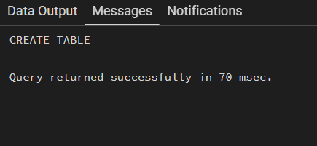
Table Created:

Insert sample records:
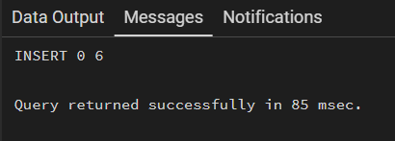

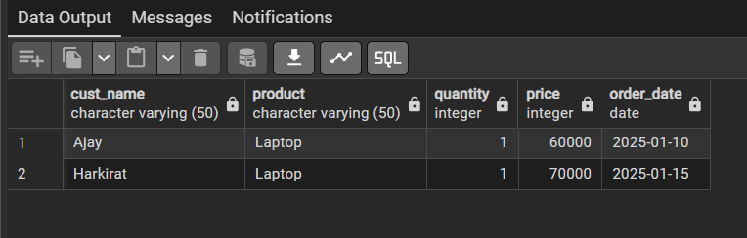
Display high priced orders

Sort by price (ascending)
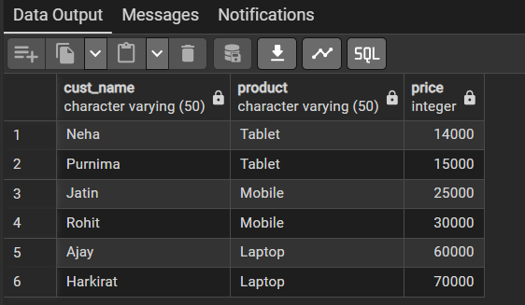

Sort by price (descending)
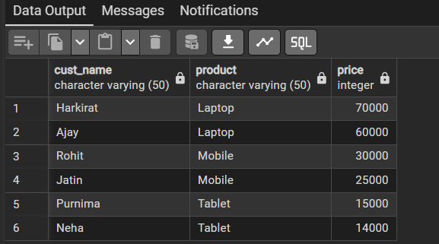

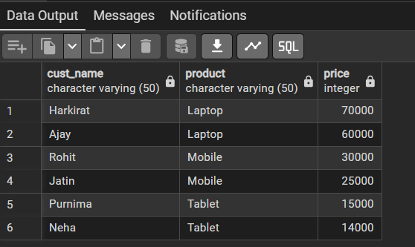
Sort by product, then price

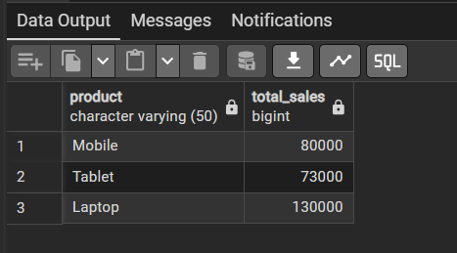
Total sales per product

Products with total sales greater than 75000
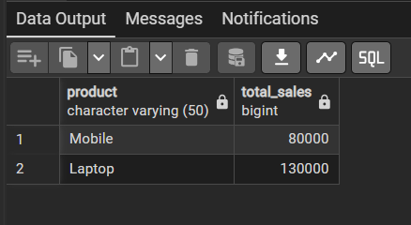

Implementing Step 6 by applying WHERE and HAVING

Learning Outcome:
- Understood the use of SQL SELECT queries in PostgreSQL
- Learned how to filter records using the WHERE clause
- Gained knowledge of sorting data using ORDER BY
- Understood grouping of data using the GROUP BY clause
- Learned to apply aggregate functions for data analysis
- Gained practical experience in executing and analyzing SQL queries.

